
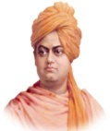
Workshop on
Traditional Siddha Varma Bone Setting Practices

Second Year Module - VI

01. Name of the Organization : Varma Research and Resource
Center
Vivekananda Kendra – NARDEP,
Kanyakumari

02. Date : 07th & 08th November 2025

03. Venue : TRC, Anjaneyapuram

04. Programme Schedule : Annexure 1

05. Participants : 20 Nos. Annexure 2

06. Photo Gallery : Annexure 3

07. Communication Method :
            - Interactive sessions
            - Live Demonstration
            - Varma Silambam & Kalari

Annexure - I
Programme Schedule
I st day 07-11-2025 ( Friday )

09.00a.m. to 10.00 a.m - Registration

10.00 a.m. to 10.15 a.m - Inaguration
i} Lighting the lamp – Dr. Kumaresan
ii) Prayer - Shanmugam ji / Achuthan
iii)Introductory Remarks - Dr. Muthusanthi

10.15 a.m to 11.15 a.m - Session - I
Varma points of Head and Neck and its Stimulation techniques
(Dr. Kumaresan)

11.15 a.m to 11. 30 a.m - Tea Break

11.30 a.m. to 01.00 p.m. - Session - II
Varma points of Head and Neck and its Stimulation techniques
(Dr.Kumaresan)

01.00 p.m to 02.00 p.m - Lunch & Rest

02.00 p.m to 04.00 p.m - Session - III
Special varma massage on Spinal cord
(Vai.Jothi Suresh Kumar)

04.00 p.m to 04.15 p.m .- Tea Break

04.15 p.m to 05.30 p.m - Session - IV
Special varma massage (Chavuttal murai)
(Thiru. Rajeshram Aasan)

05.30 p.m to 07.30 p.m - Session - V
Varma Silambam
(Thiru. Rajeshram Aasan)

07.30 p.m to 08.30 p.m - Dinner

08.30 p.m to 09.30 p.m - Session - VI
Happy Assembly
(C.Vijayaragavan)

09.30 p.m - Switch off

2nd day 08-11-2025 ( Saturday)
05.30 a.m to 06.30 a.m - Session – VII
Pratasmaran, Yoga
(C.Vijayaragavan,Udhaykumar)

06.30 a.m. to 07.30 a.m. - Session - VIII
Varma Silambam
(Thiru.Rajeshram Aasan)

07.30 a.m to 08.30 a.m - Ablution

08.30 a.m. to 09.30 a.m. - Breakfast

09.30 a.m to 11.00 a.m - Session -IX
Overview of Varma Nadi and Saram
(Dr. Kannan Rajaram)

11.00 a.m to 11.15 a.m - Tea Break

11.15 a.m to 01.00 p.m - Session -X
Overview of Varma Nadi and Saram
(Dr. Kannan Rajaram)

01.00 p.m to 02.00 p.m - Lunch & Rest

02.00p.m to 04.00 p.m - Session - XI
Anatomy and Clinical Anatomy of Upper Limb – Dr.Balaji

Annexure – II
Total No. of Participants: 20

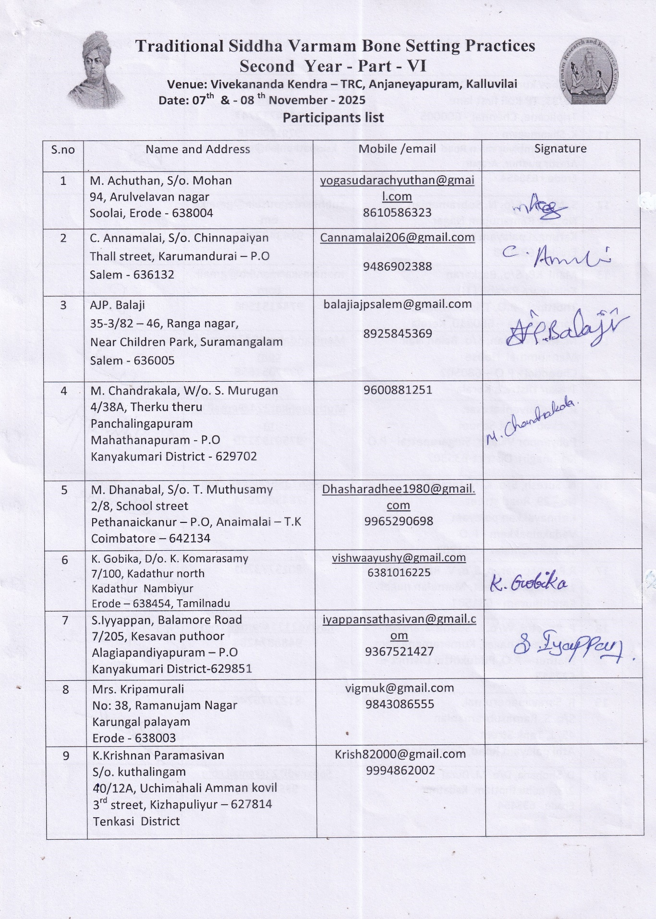

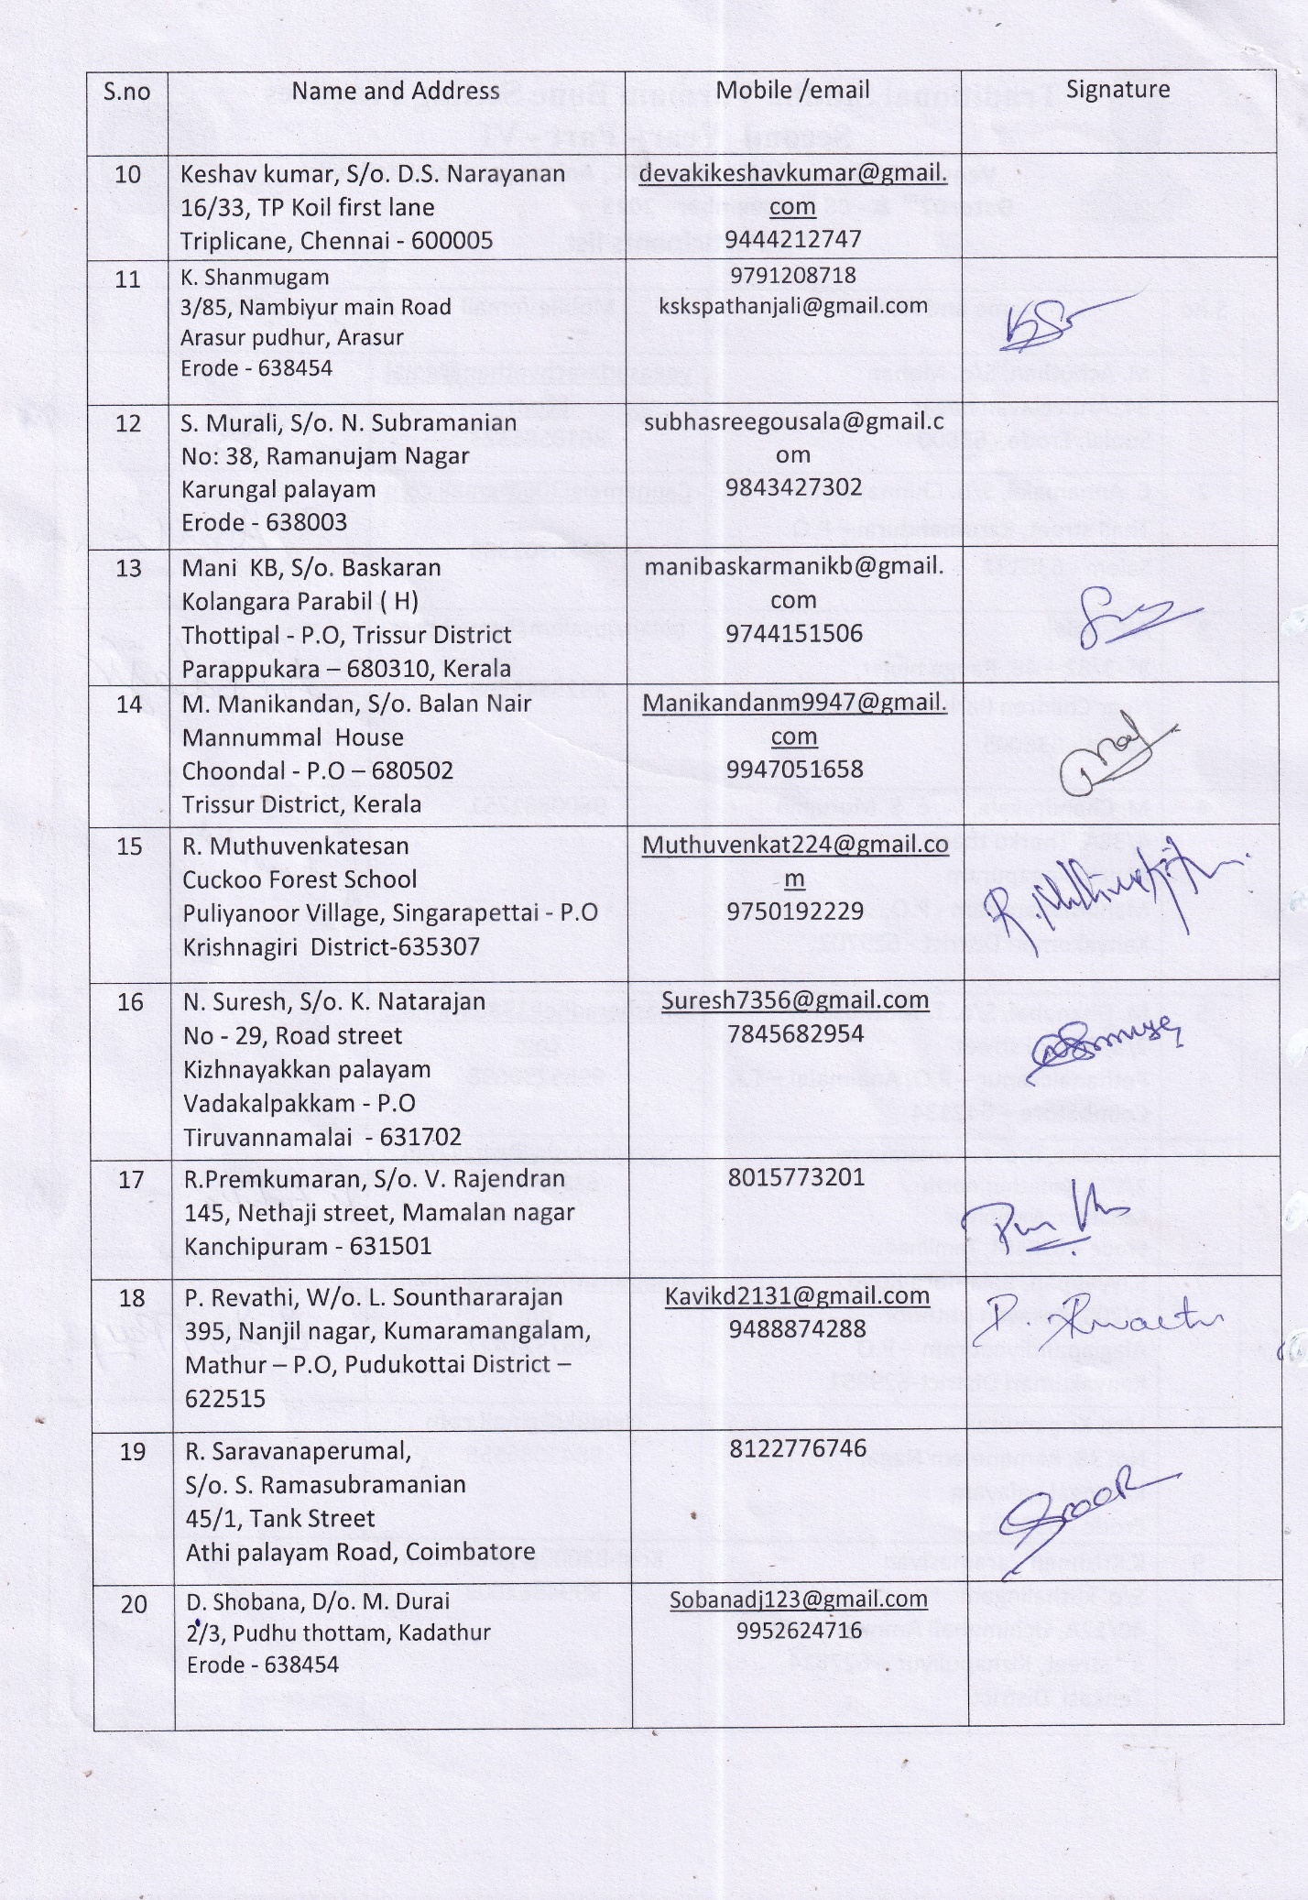

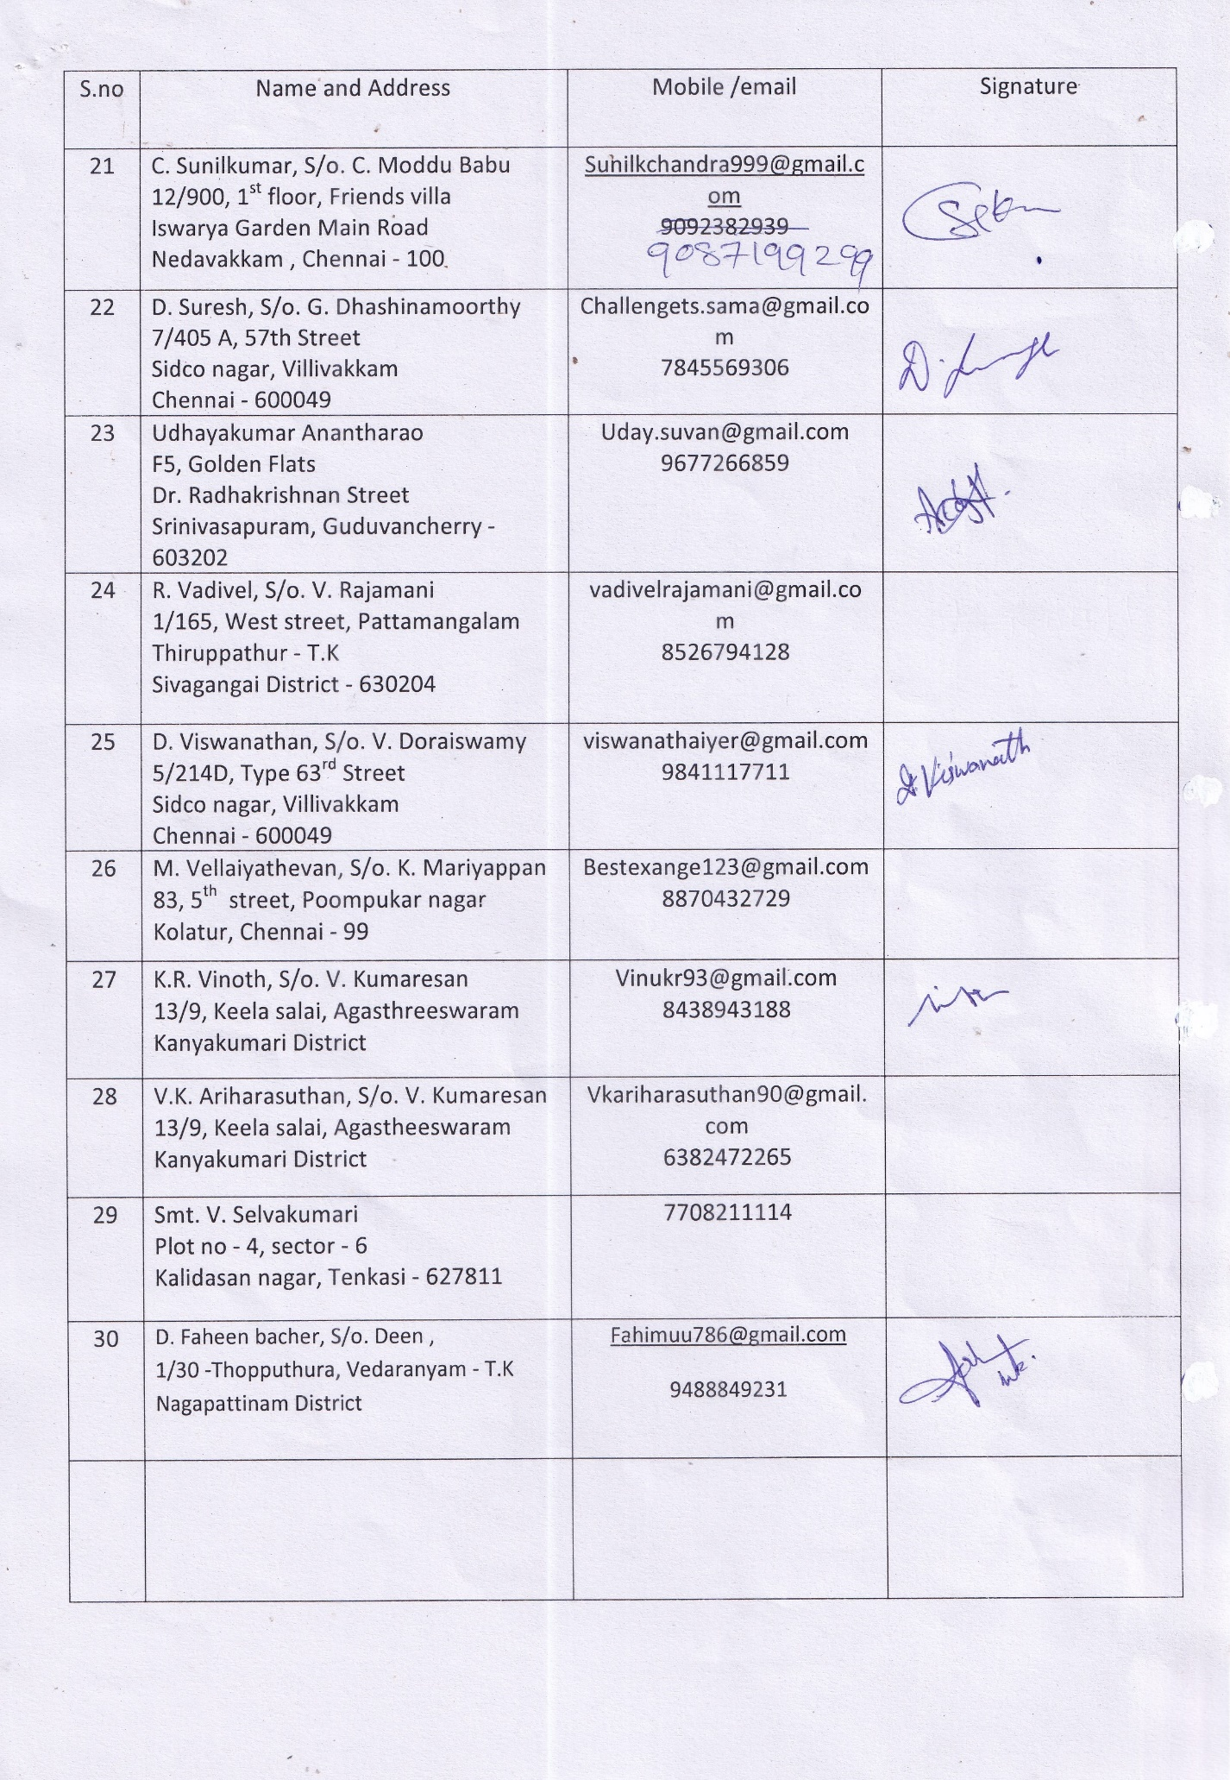

Annexure – III
Photo Gallery

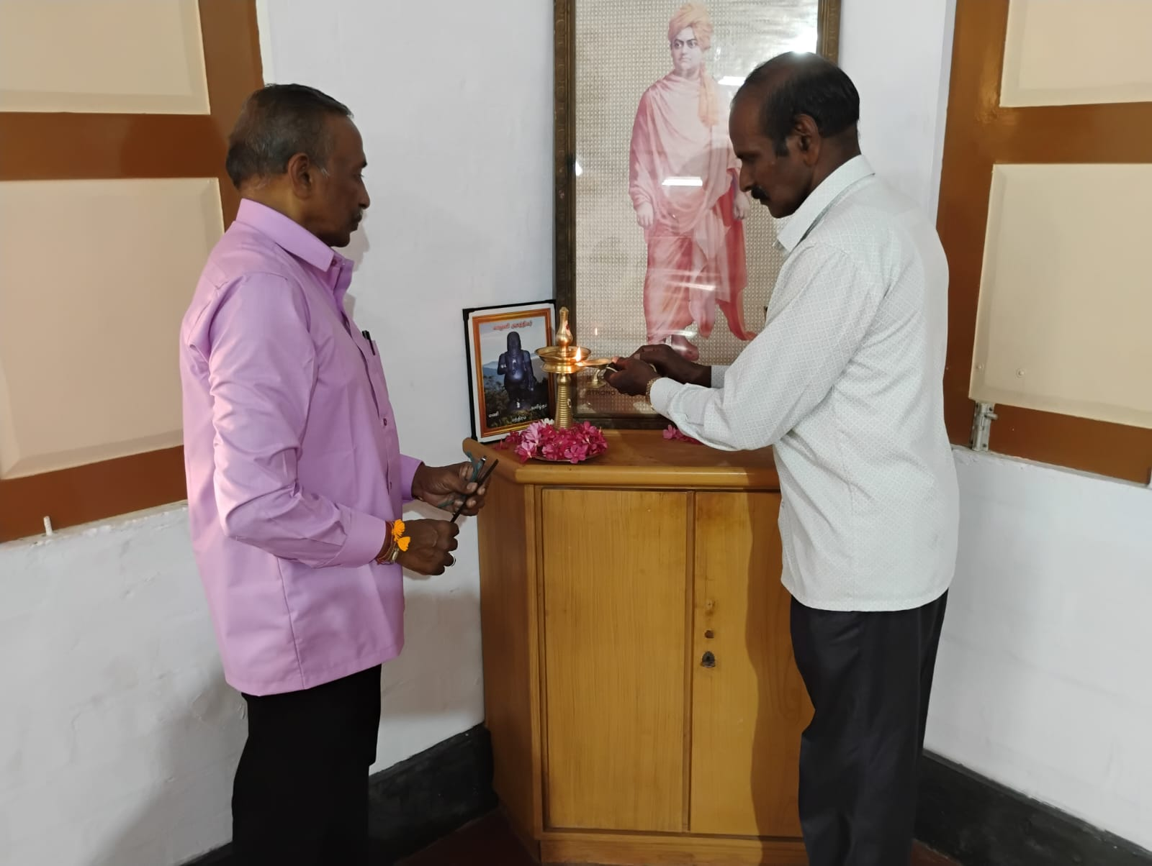
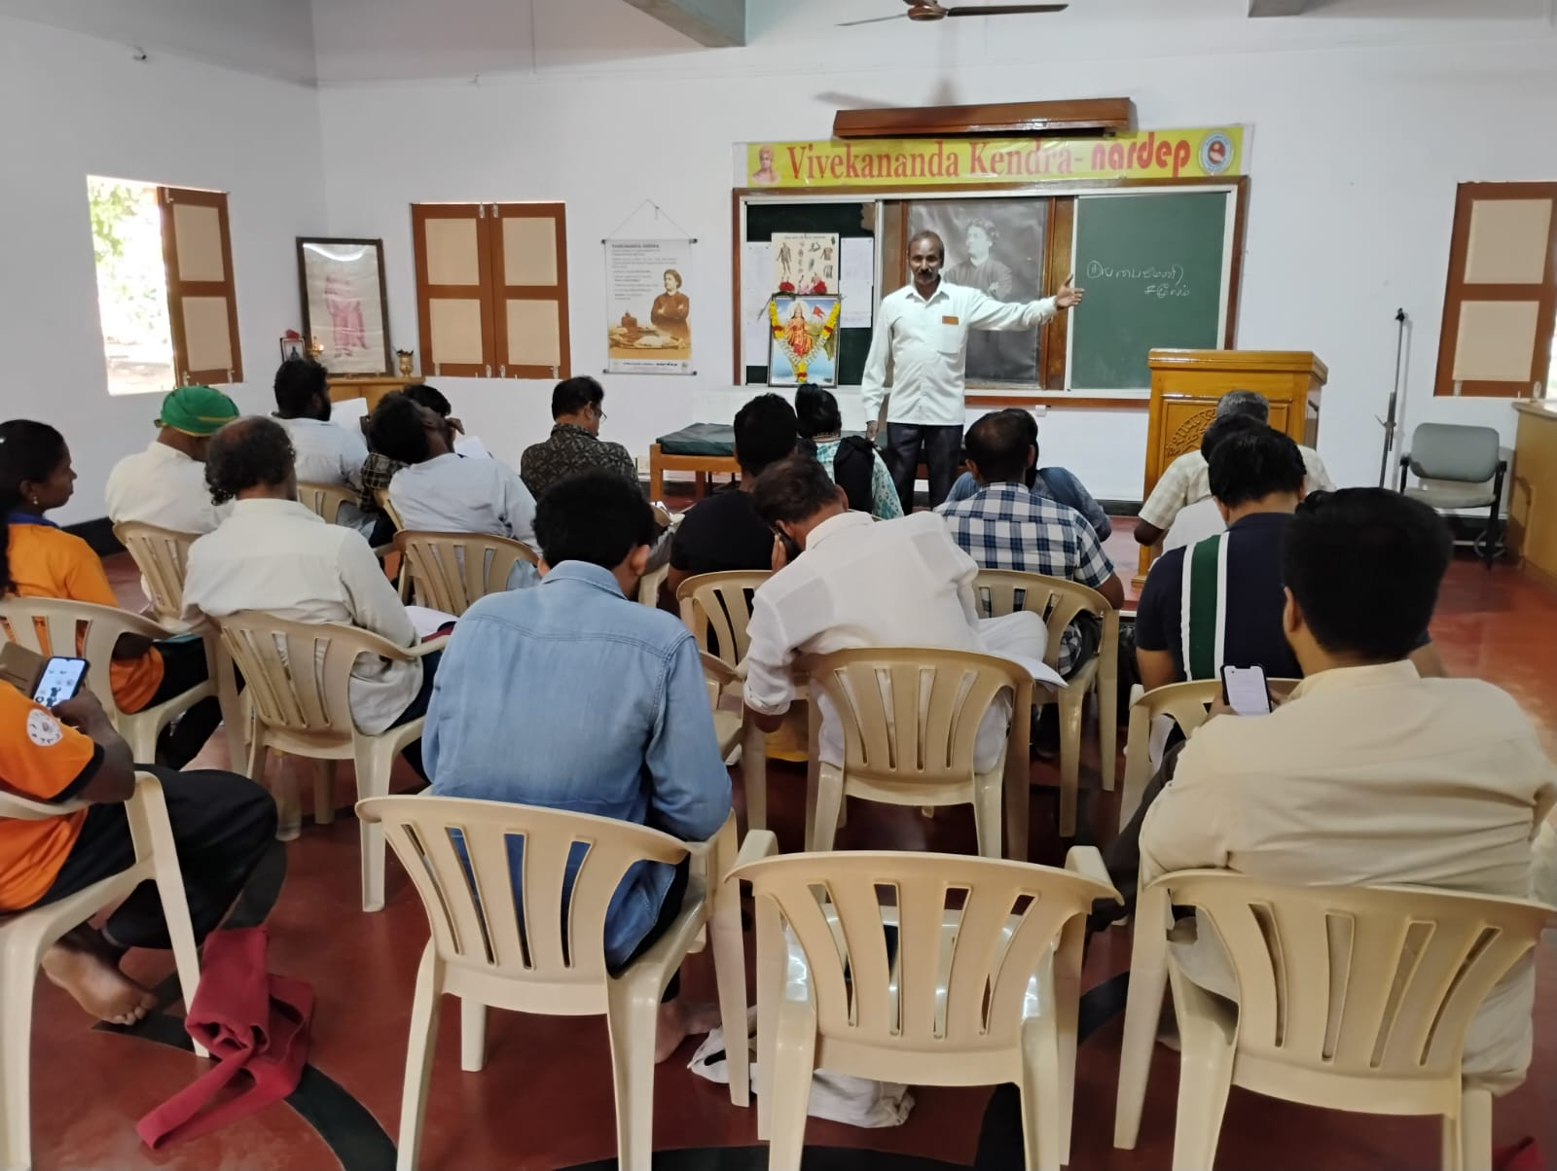
Lighting the lamp – Dr. Kumaresan

Varma points of Head and Neck and its Stimulation techniques
- Dr.Kumaresan
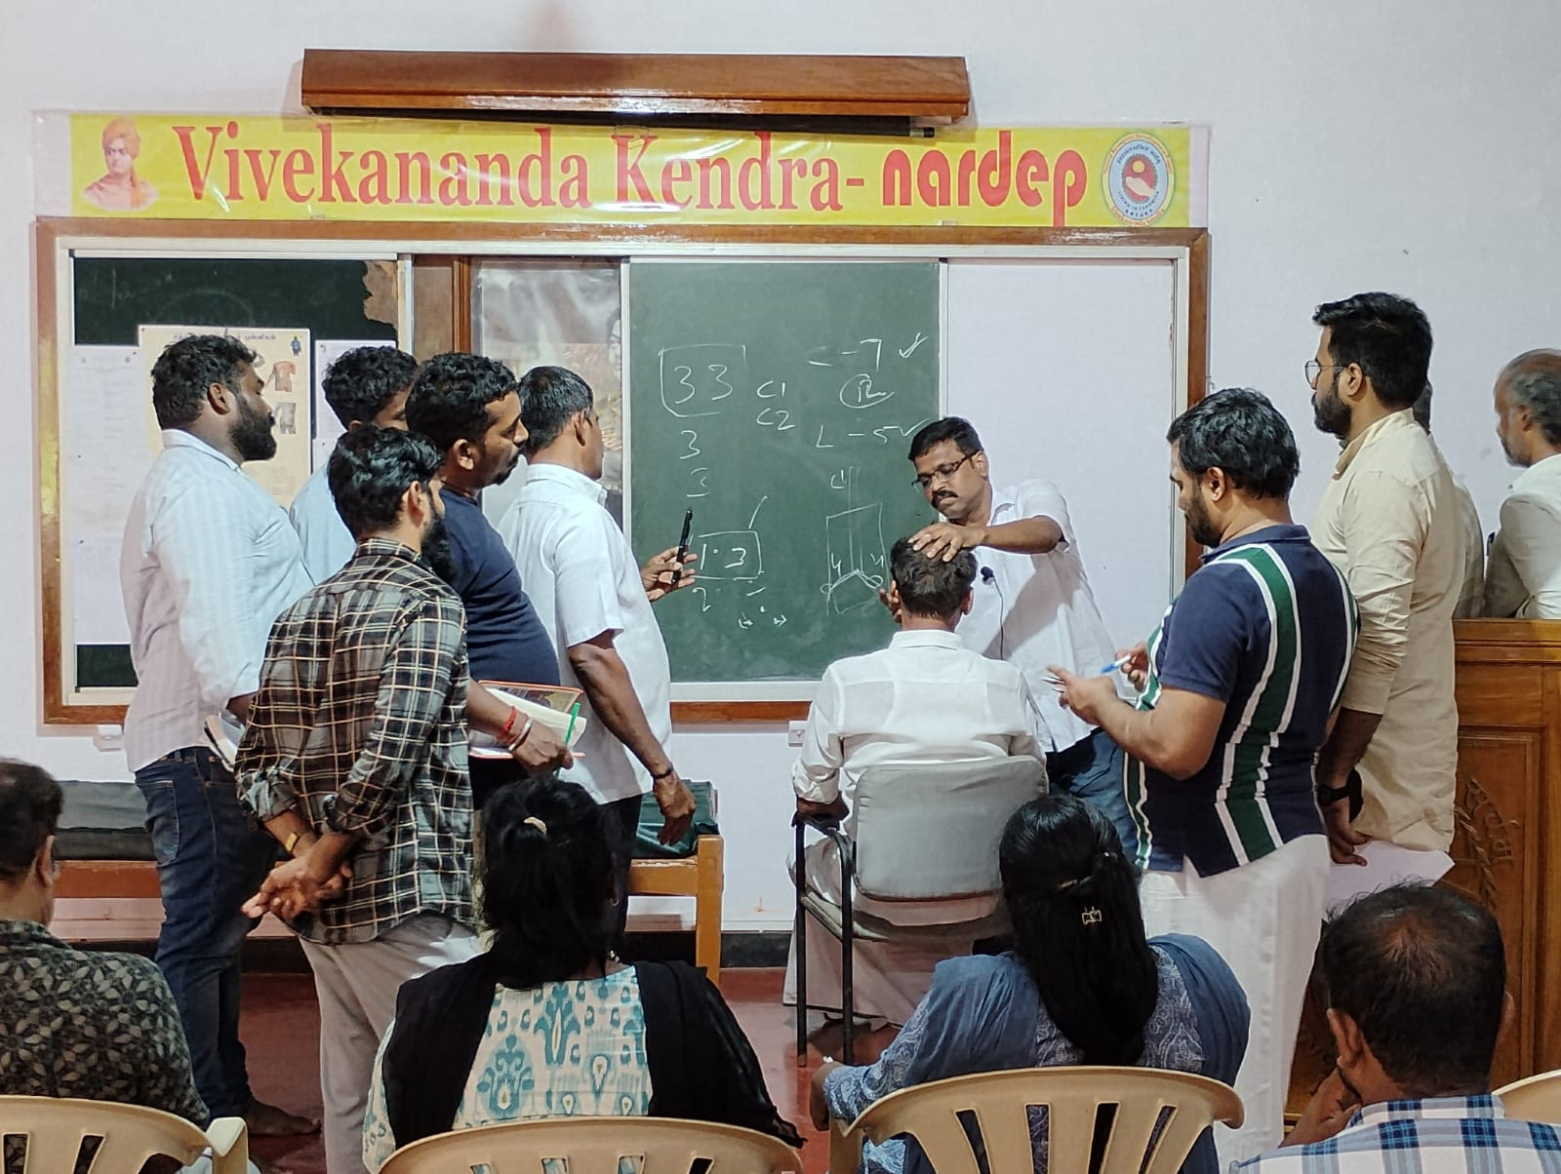 Special varma massage of Spinal cord - Vai.Jothi Suresh Kumar
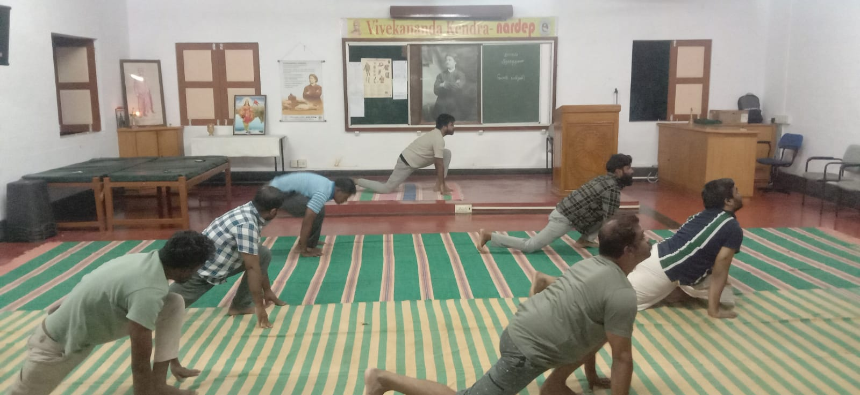
Pratasmaran, Yoga - Shri.Udhayakumar

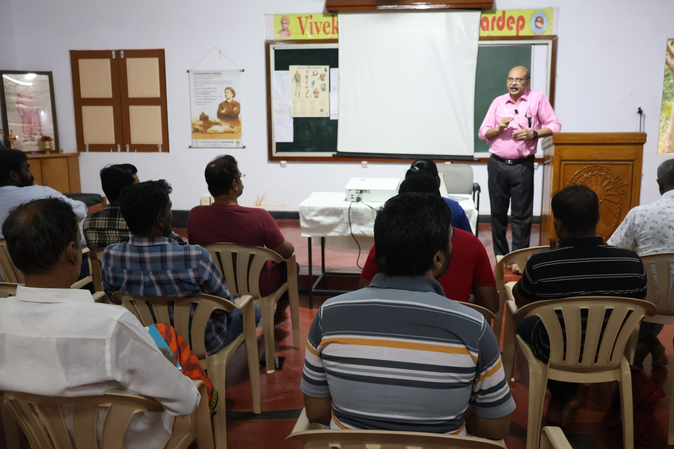
Overview of Varma Nadi and Saram - Dr.Kannan Rajaram

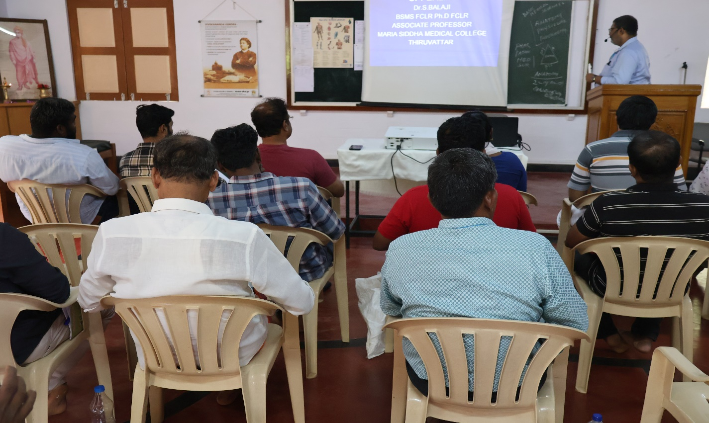
Clinical Anatomy of Upper Limb – Dr.Balaji

